

# Model NO.: ON-AVR8008T-NGS-V4 **H.265 8CH 4K-N DVR with 1 SATA**

**APP: XMEye pro**

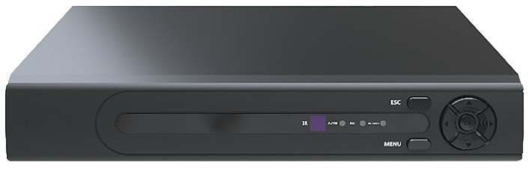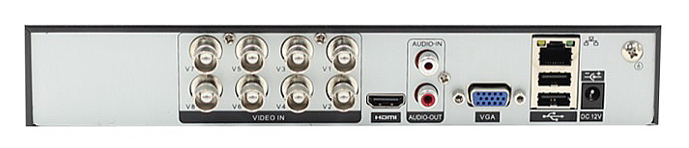

**Feature：**

* Support 8ch 4K-N unreal-time encoding;
* Support XVI,AHD, TVI,CVI, CVBS, IP video input;
* support VGA maximum 1080P output, HDMI up to 4K output;
* Mini 1U Case, 1 SATA(Up to 14TB);
* 1*10/100Mbps auto-sensing Ethernet port, RJ45 port；
* Automatic networking support, a key to add equipment;
* Support the Onvif protocol;
* Support GB28181 (Optional);
* Cloud services, P2P, alarm information push to phone;
* Support remote access, support ARSP;
* Support DHCP, FTP, DNS, DDNS, NTP, UPNP, EMAIL,

3G, WIFI, IP search, Alarm center, etc ;

* Mobile phone remote monitoring (iOS, Android);
* Multi browser access (IE, Chrome, Firefox, Safari);
* Support for more than twenty languages;
* Perfect protection circuit,unique triple watchdog function
* Support WEB, CMS, VMS, MYEYE Platform;
* Support coaxial control
* Support coaxial audio
* Support human detection, face detection Vehicle detection and other intelligence

**Specification：**

|  |  |  |
| --- | --- | --- |
|  | **Model** | **ON-AVR8008T-NGS-V4** |
| System | processor | NT98332 |
| Video | Codec | H.265+/H.265/H.264 |
| Preview | 8*4K-N@15fps(6 in 1) /8*5M@12fps(6 in 1) /8*4M@15fps（6 in 1）/8*3M@18fps（6 in 1）/8*1080P（6 in 1）default4K-N |
| Encode | 8*4K-N@9fps(6 in 1) /8*5M@8fps(6 in 1) /8*4M@10fps（6 in 1）/8*3M@12fps（6 in 1）/8*1080P@18fps（6 in 1）default4K-N |
| Decode | 8*4K-N@9fps(6 in 1) /8*5M@8fps(6 in 1) /8*4M@10fps（6 in 1）/8*3M@12fps（6 in 1）/8*1080P@18fps（6 in 1）default4K-N |
| Multi-mode | Analog: 8ch 4K-N |
| hybrid：8ch4K-N（analog）+4ch5M（network） |
| IP:16ch 1080P/8ch 5M |
| Playback | 8ch |
| Audio | Coaxial audio | support |
| Compression | G.711a |
| Intercom | Support |
| Management | Record mode | Manual>Alarm>Motion detection>Timing |
| Inquire mode | Inquire by Time/Calendar/Event/Channel |
| Storage mode | HDD Storage, Network Storage |
| Backup | Network, USB, SATA |
| Interface | Video input | 8*BNC（Support Coaxitron) |
| HDMI output | 1*HDMI (MAX:4K) |
| VGA output | 1*VGA (MAX:1080P) |
| Audio I/O | 1/1 |
| Alarm I/O | 0/0 |
| Ethernet port | 1*10/100Mbps Ethernet port, RJ45 port |
| PTZ control | Support for multiple PTZ protocol |
| USB Port | 2*USB2.0 ports |
| HDD | 1*SATA interface (Up to 14TB) |
| General | Temperature | 0 ℃ - + 55 ℃ |
| Humidity | 10% -90% RH |
| Power supply | 12V/2A |
| Consumption | <10W（Without HDD) |
| Weight | Around1KG |
| Dimension | 255mm(L)* 215mm(W)* 44mm(H) |