Model NO.: ON-N6432G-P16-AI

H.265 32CH 12MP POE NVR with 4pcs SATA APP: Superlive Plus
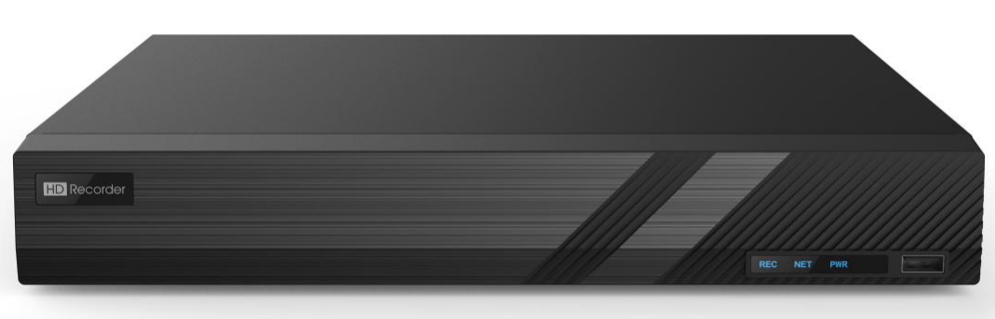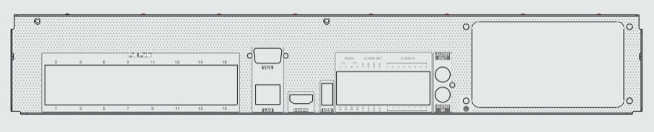

Key Features:
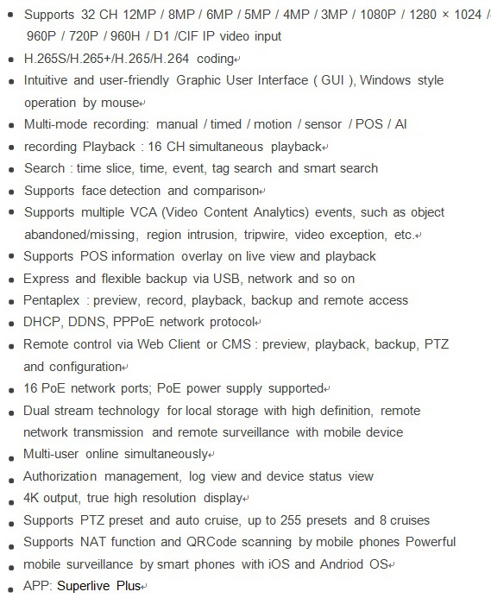

Specifications:
Model |  | ON-N6432G-P16-AI
System | OS | Embedded Linux
Video | Network Input | 32 CH IPC input
 | Incoming Bandwidth | 256Mbps
 | Outgoing Bandwidth | 256Mbps
 | Network Input Resolution | 12MP / 8MP / 6MP / 5MP / 4MP / 3MP / 1080P / 1280 × 1024 /  960P / 720P / 960H / D1 /CIF
 | Output | HDMI × 1 : 3840×2160@60fps/3840×2160@30fps/ 1920×1080/1280×1024/1024×768  VGA × 1 : 1920×1080/1280×1024/1024×768
 | Compression | H.265S/H.265+/H.265/H.264
 | Multi-screen Display | 1/4/6/8/9/13/16/25/32/36
Audio | Network Input | 32 CH IPC audio input
 | 2-way Audio | RCA × 1
 | Local Output | RCA × 1
 | Compression | G.711(U/A)
Record | Record Stream | Dual stream recording
 | Resolution | 12MP@20fps; 8MP/ 6MP/5MP/4MP/3MP/1080P/1280×1024/  960P/ 720P/960H/D1/CIF@30fps(NTSC)/25fps(PAL)
 | Mode | Manual/ timed/ motion/ sensor/ POS/AI recording
 | ANR | Automatic network replenishment (Yes)
Decoding Capability | Live View/ Playback | 1CH 12MP/4CH 5MP/9CH 720P/16CH D1
Playback | Simultaneous Playback | Max 16 CH
 | Search | Time slice / time / event / tag search
 | Smart Search | Highlighted color to display the camera record in a certain period of time, different colors refers to different record events
 | Function | Play, pause, FF, FB, digital zoom, etc.
Alarm | Mode | Manual, sensor, motion, exception, smart events
 | Input | 16 CH local alarm input; supports IPC alarm input
 | Output | 4 CH
 | Triggering | Record, snapshot, buzzer, preset, e-mail, etc.
Face | Channel | 32 CH
 | Face Picture Database | 32 libraries  5000 Face Pictures
 | Computing Capability | 180 pictures / minute
 | Face Picture Search | Search by picture is supported
 | Database Management | Add, modify, delete and search face pictures
 | Face Picture Adding | Add face pictures through APP, WEB and external import
 | Face Picture Comparison | Support allow list, block list and stranger match alarm
 | Track | Track display on a map
 | Statistic Graph of Face Information | Bar graph
 | Statistic Mode of Face Information | Statistics by day, week, month, quarter as well as customized time period
Video Structure Analysis | Human/Vehicle Classification | Yes
Other Functions | Fisheye | Supports fisheye dewarping via Web Client and mobile APP
 | Plate Recognition | Yes
 | PoE Port | RJ45 × 16
 | Standard | IEEE802.3af
 | Output Power | ≤ 150W
 | Interface | RJ45 10 / 100 / 1000 Mbps × 1
 | Protocol | TCP / IP, PPPoE, DHCP, DNS, DDNS, UPnP, NTP, SMTP, HTTP, HTTPs, 802.1x, ONVIF, etc.
 | Client Connection | Max.20 users access
 | OS | iOS, Andriod
 | HDD Interface | SATA × 4, max 8T per HDD
 | Local Backup | U disk, USB mobile HDD
 | Network Backup | Yes
 | RS 485 | Yes (full-duplex), connect to PTZ or keyboard
 | USB | USB 2.0 × 1 , USB 3.0 × 1
 | Remote Controller | Optional
 | Language | 30 languages (like English, French, Arabic, Spanish, etc.)
 | Power Supply | ATX 292W
 | Consumption | ≤ 15W ( without HDD and PoE power supply )
 | Dimensions (mm) | 440 × 390 × 70 ( W × D × H )
 | Working Environment | -10 ~50 °C，10% ~ 90% humidity
 | Certificate | CE, FCC
 | Environmental Protection | Complies with Directive EU RoHS, REACH and WEEE

